**Exercise 1: Control Structures**

create database ControlStructures;

use ControlStructures;

CREATE TABLE customers (

customer_id INTEGER PRIMARY KEY,

name VARCHAR(50),

age INTEGER,

balance NUMERIC(10, 2),

isvip BOOLEAN DEFAULT FALSE

);

CREATE TABLE loans (

loan_id INTEGER PRIMARY KEY,

customer_id INTEGER REFERENCES customers(customer_id),

interest_rate NUMERIC(5, 2),

due_date DATE

);

INSERT INTO customers (customer_id, name, age, balance, isvip) VALUES

(1, 'Alice', 65, 15000.00, FALSE),

(2, 'Bob', 45, 8000.00, FALSE),

(3, 'Charlie', 70, 5000.00, FALSE),

(4, 'Diana', 30, 12000.00, FALSE);

INSERT INTO loans (loan_id, customer_id, interest_rate, due_date) VALUES

(101, 1, 8.5, CURRENT_DATE + INTERVAL 10 DAY),

(102, 2, 9.0, CURRENT_DATE + INTERVAL 40 DAY),

(103, 3, 7.5, CURRENT_DATE + INTERVAL 5 DAY),

(104, 4, 8.0, CURRENT_DATE + INTERVAL 25 DAY);

select * from customers;

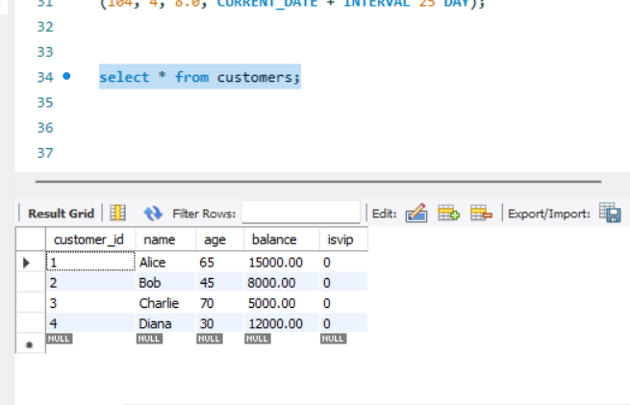

**Scenario 1:**

CREATE PROCEDURE ApplyInterestDiscount()

BEGIN

DECLARE done INT DEFAULT FALSE;

DECLARE loanId INT;

DECLARE cur CURSOR FOR

SELECT l.loan_id

FROM loans l

JOIN customers c ON c.customer_id = l.customer_id

WHERE c.age > 60;

DECLARE CONTINUE HANDLER FOR NOT FOUND SET done = TRUE;

OPEN cur;

read_loop: LOOP

FETCH cur INTO loanId;

IF done THEN

LEAVE read_loop;

END IF;

UPDATE loans

SET interest_rate = interest_rate * 0.99

WHERE loan_id = loanId;

END LOOP;

CLOSE cur;

END$$

Call ApplyInterestDiscount();

select * from loans;

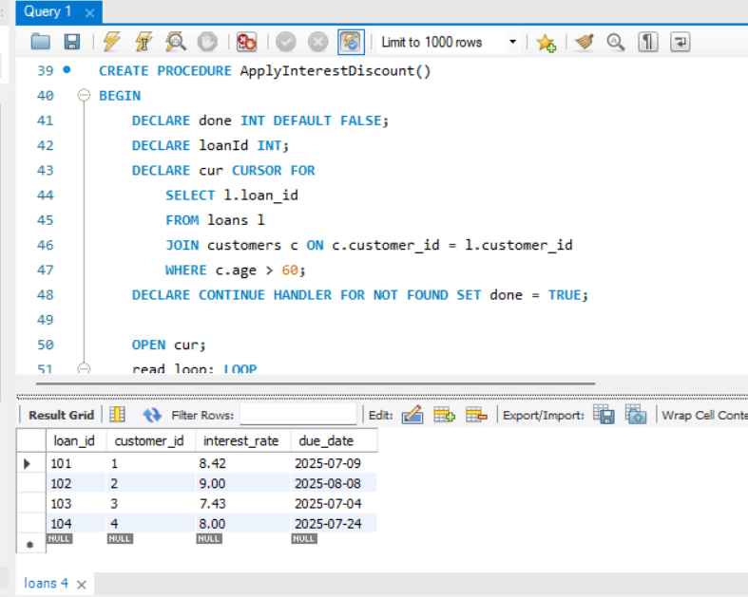

**Scenario 2:**

CREATE PROCEDURE PromoteToVIP()

BEGIN

DECLARE done INT DEFAULT FALSE;

DECLARE custId INT;

DECLARE cur CURSOR FOR

SELECT customer_id FROM customers WHERE balance > 10000;

DECLARE CONTINUE HANDLER FOR NOT FOUND SET done = TRUE;

OPEN cur;

read_loop: LOOP

FETCH cur INTO custId;

IF done THEN

LEAVE read_loop;

END IF;

UPDATE customers

SET isvip = TRUE

WHERE customer_id = custId;

END LOOP;

CLOSE cur;

END$$

DELIMITER ;

CALL PromoteToVIP();

select * from customers;

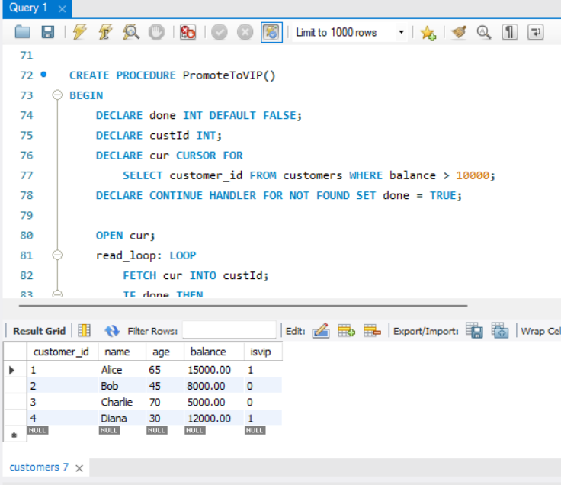

**Scenario 3:**

CREATE DEFINER=`root`@`localhost` PROCEDURE `SendLoanReminders`()

BEGIN

DECLARE done INT DEFAULT FALSE;

DECLARE loanId INT;

DECLARE custName VARCHAR(50);

DECLARE dueDate DATE;

DECLARE cur CURSOR FOR

SELECT l.loan_id, c.name, l.due_date

FROM loans l

JOIN customers c ON c.customer_id = l.customer_id

WHERE l.due_date BETWEEN CURDATE() AND CURDATE() + INTERVAL 30 DAY;

DECLARE CONTINUE HANDLER FOR NOT FOUND SET done = TRUE;

OPEN cur;

read_loop: LOOP

FETCH cur INTO loanId, custName, dueDate;

IF done THEN

LEAVE read_loop;

END IF;

SELECT CONCAT('Reminder: ', custName, '''s loan (ID ', loanId, ') is due on ', DATE_FORMAT(dueDate, '%d-%b-%Y')) AS message;

END LOOP;

CLOSE cur;

END

